**MINI PROJECT**

**Topic: House Boat Booking System**

**Presented by**

**Akash Babu**

**Rollno 02**

**S3 LE MCA**

**ABSTRACT**

This Project on House Boat Booking Which is a Major part of Backwater tourism Especially in kerala. Traditionally selecting a House Boat directly may cause trouble as you may be vheated ,with this online houseboat booking system you can book a houseboat at an affordable price and avoid last minute unavailability and price variations.

The API is used for forecasting the the weather informations for that day using google API.

**Tables**

**Tbl_details**

|  |  |  |  |
| --- | --- | --- | --- |
| **Name** | **Type** | **Size** | **Key** |
| pid | Int | 10 |  |
| Name | varchar | 15 |  |
| Phone | varchar | 20 |  |
| Email | varchar | 20 | Primary key |
| Place | varchar | 20 |  |

**Tbl_login**

|  |  |  |  |
| --- | --- | --- | --- |
| **Name** | **Type** | **Size** | **Key** |
| Reg_id | Int | 11 | Primary key |
| Email | Varchar | 20 | Foreign key |
| Phone | Varchar | 20 |  |
| Password | varchar | 10 |  |
| status | varchar | 20 |  |
| Type | varchar | 30 |  |

**Tbl_place**

|  |  |  |  |
| --- | --- | --- | --- |
| **Name** | **Type** | **Size** | **Key** |
| cat_id | int | 11 | Primary key |
| Cat_name | Varchar | 15 |  |

**Tbl_boat**

|  |  |  |  |
| --- | --- | --- | --- |
| **Name** | **Type** | **Size** | **Key** |
| b_id | Int | 10 | Primary key |
| bname | Varchar | 10 |  |
| Description | Varchar | 20 |  |
| photo | varchar | 20 |  |
| phone | Varchar | 15 |  |

**Tbl_star**

|  |  |  |  |
| --- | --- | --- | --- |
| **Name** | **Type** | **Size** | **Key** |
| r_id | Int | 10 | Primary key |
| pid | Int | 10 | Foreign key |
| rating | Int | 15 |  |
| review | varchar | 20 |  |

**Tbl_cat**

|  |  |  |  |
| --- | --- | --- | --- |
| **Name** | **Type** | **Size** | **Key** |
| place_id | Int | 5 | Primary key |
| placename | varchar | 20 | Not null |
|  |  |  |  |

**Tbl_booking**

|  |  |  |  |
| --- | --- | --- | --- |
| **Name** | **Type** | **Size** | **Key** |
| Bkid | Int | 5 | Primary key |
| bid | Int | 20 | Foreign key |
| Name | Varchar |  |  |
| Book date | Date |  |  |
| Book time | Time |  |  |
| package | varchar | 30 |  |

**Data Flow Diagrams**

**Context Level**

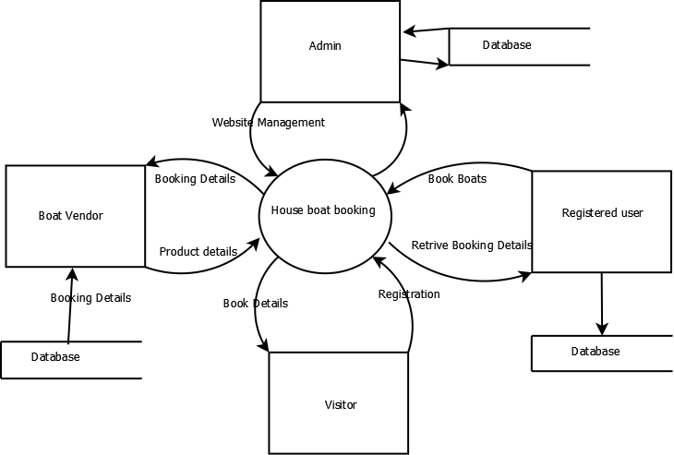

**Level 0 User**

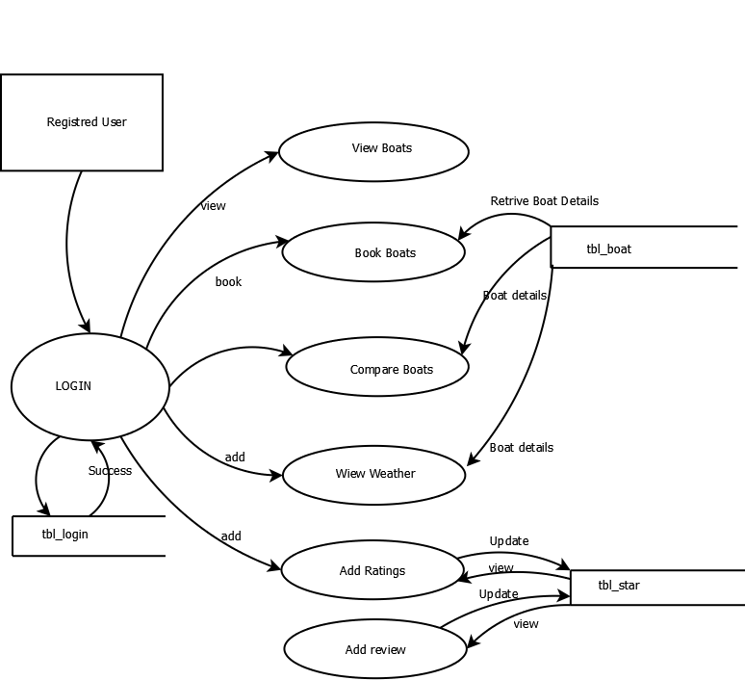

**Level 0 Vendor**

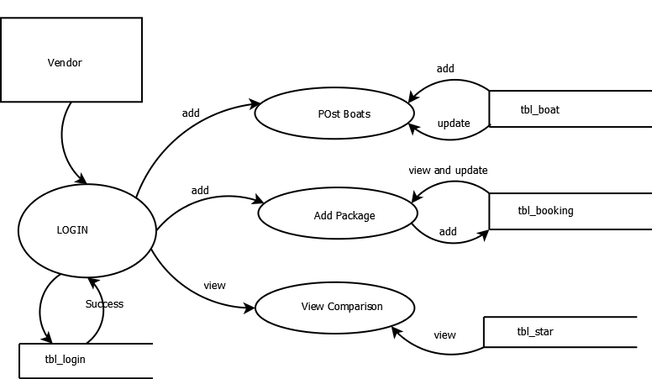

**Level 0 visitor**

